WHY CISITCELEBES DIGITAL AGENCY?

Among so many others, we have become the pioneer of digital partner who want nothing but success for our clients. That is why we give all-inclusive digital necessity and 100% transparency to our clients.



WHY DIGITAL MARKETING?

With the growth of digital users in the world, a new way of promoting products emerges. Digital Marketing holds so many opportunities for businesses in the future, with its endless potential and benefits.

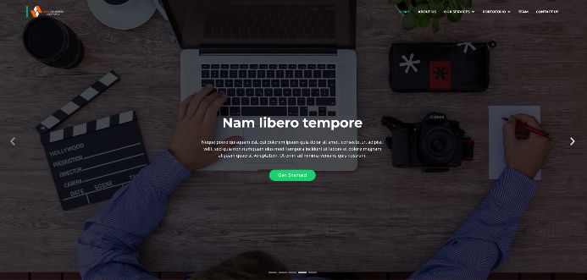

“Content marketing is a commitment, not a campaign”

Content marketing is not a one and done. It’s a constant factor in everything you do in digital marketing. Never treat content marketing like it’s not an integral part of your digital marketing plan.

“Business has only two functions – marketing and innovation”

In modern business, regardless of industry, a successful company focuses on innovation and telling the stories of that innovation. Everything else is simply the result of these actions.